**Project Design Phase**

**Problem – Solution Fit Template**

|  |  |
| --- | --- |
| Date | 15 February 2026 |
| Team ID | LTVIP2026TMIDS84622 |
| Project Name | FlightFinder – Navigating Your Air Travel Options |
| Maximum Marks | 2 Marks |

**Problem – Solution Fit Template:**

Problem–Solution Fit means identifying the real challenges faced by travelers while booking flights and ensuring that the FlightFinder platform effectively solves those problems through a simple, secure, and reliable booking experience.

FlightFinder addresses common issues such as scattered flight information, confusing booking processes, lack of real-time availability, and concerns about secure payments. The platform simplifies the entire journey—from searching and comparing flights to booking and receiving instant confirmation—ensuring the solution directly matches customer needs.

**Purpose:**

❑ **Solve complex flight booking problems in a way that fits the needs of modern travelers**, including students, professionals, and frequent flyers.

❑ **Increase adoption by using familiar online behaviors**, such as web-based search, mobile-friendly interfaces, and secure digital payments.

❑ **Sharpen communication and marketing strategies** by highlighting key benefits like real-time flight availability, easy comparison, and secure transactions.

❑ **Increase customer trust and engagement** by solving frequent annoyances such as hidden charges, price confusion, and delayed confirmations.

❑ **Understand the current travel booking challenges** and improve them by offering a centralized, user-friendly, and efficient platform.

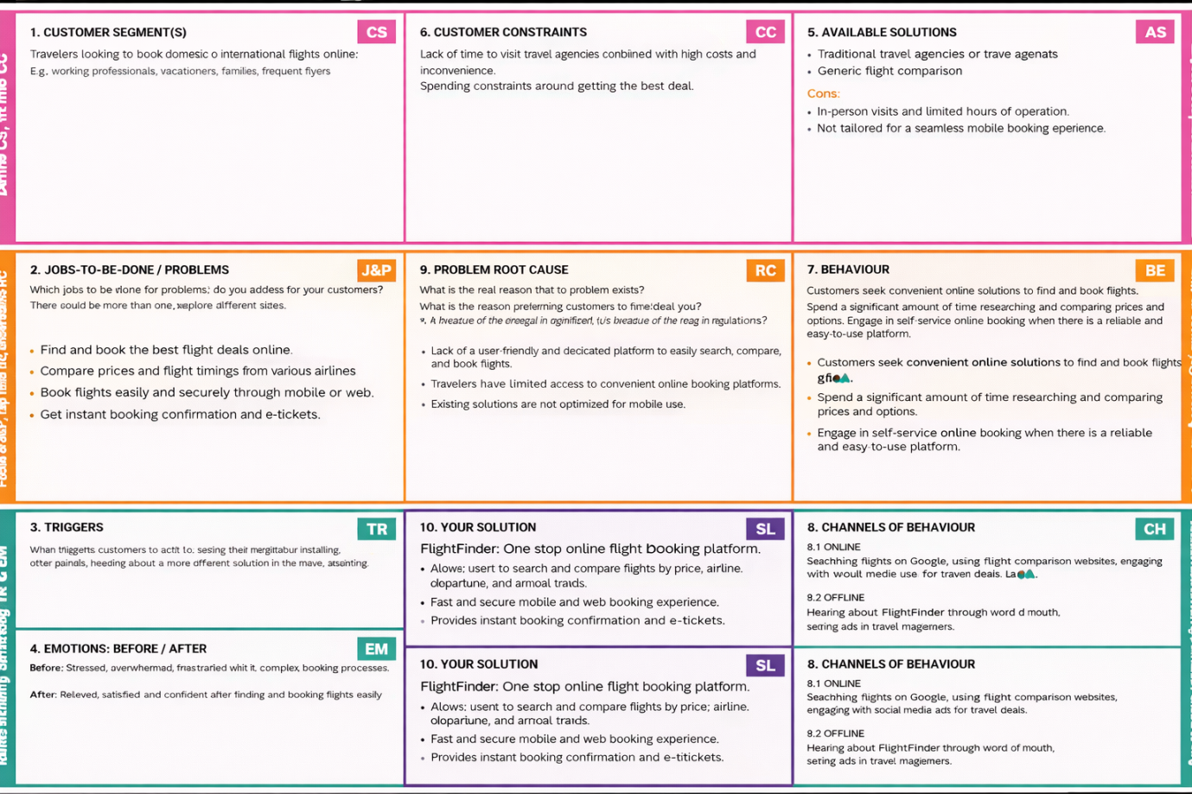

## 1 CUSTOMER SEGMENT(S)

* Students traveling for education or vacations
* Working professionals traveling for business
* Families planning trips
* Frequent travelers
* Users who prefer online booking platform.

## 2 JOBS-TO-BE-DONE / PROBLEMS

* Search and compare flights easily
* Find the best ticket prices
* Book flights securely through web or mobile
* Get instant booking confirmation and e-tickets
* Avoid visiting multiple airline websites

## 3 TRIGGERS

* Planning a vacation or business trip
* Seeing flight offers or discounts
* Urgent travel requirement
* Flight price alerts
* Recommendation from friends or ads

## 4 EMOTIONS: BEFORE / AFTER

**Before:**

* Confused
* Stressed
* Frustrated
* Worried about payment security

**After:**

* Relieved
* Confident
* Satisfied
* Happy with quick confirmation

## 5 AVAILABLE SOLUTIONS

* Traditional travel agencies
* Airline official websites
* Generic flight comparison websites

**Cons:**

* Time-consuming
* Scattered information
* Not always mobile-friendly
* Lack of centralized booking

## 6 CUSTOMER CONSTRAINTS

* Limited time
* Budget constraints
* Complex booking processes
* Lack of clear real-time availability
* Fear of hidden charges

## 7 BEHAVIOUR

* Searching flights on Google
* Comparing prices across multiple websites
* Reading reviews before booking
* Looking for discount offers
* Booking through reliable platforms

## 8 CHANNELS OF BEHAVIOUR

**Online:**

* Google search
* Travel comparison websites
* Social media ads
* Email notifications

**Offline:**

* Word of mouth
* Travel agency recommendations

## 9 PROBLEM ROOT CAUSE

* No single centralized platform for easy comparison
* Complicated user interfaces
* Lack of transparent pricing
* Poor integration of real-time data

## 10 YOUR SOLUTION

**FlightFinder – One-stop online flight booking platform**

* Search and compare flights easily
* Real-time flight availability
* Secure payment integration
* Instant booking confirmation
* Simple and user-friendly interface